# **This document is a rough idea of our first prototype for our product. If you need any additional context or have any input please don’t hesitate to contact us.**

# 

# 

# **Design We Are Trying to Mimic**

[FORM Lifting: Revolutionize the way you train by Scott Mahr — Kickstarter](https://www.kickstarter.com/projects/formlifting/formcollar/)

[FORM Lifting Collar Review 2025 | Garage Gym Reviews](https://www.garagegymreviews.com/form-lifting-collar-review)

# 

# **Electronics Being Held Inside the Barbell Clip**

**Arduino Nano 33 BLE Sense**- <https://www.amazon.com/Nano-BLE-Sense-Rev2-ABX00069/dp/B0BQHXVSGM/ref=asc_df_B0BQHXVSGM?mcid=f8a43e1b67ad3a9aacdbfa9cb290e320&hvocijid=15449847686793993850-B0BQHXVSGM-&hvexpln=73&tag=hyprod-20&linkCode=df0&hvadid=721245378154&hvpos=&hvnetw=g&hvrand=15449847686793993850&hvpone=&hvptwo=&hvqmt=&hvdev=c&hvdvcmdl=&hvlocint=&hvlocphy=9060451&hvtargid=pla-2281435179338&psc=1>

**TP4056 LiPo Charging Module-** <https://www.amazon.com/HiLetgo-Lithium-Charging-Protection-Functions/dp/B07PKND8KG/ref=asc_df_B07PKND8KG?mcid=582532d88b30334da0eb72382cf0d57a&hvocijid=806802862098911036-B07PKND8KG-&hvexpln=73&tag=hyprod-20&linkCode=df0&hvadid=721245378154&hvpos=&hvnetw=g&hvrand=806802862098911036&hvpone=&hvptwo=&hvqmt=&hvdev=c&hvdvcmdl=&hvlocint=&hvlocphy=9060451&hvtargid=pla-2281435178618&psc=1>

**Wires-**

**No specific link**

**3.7V LiPo Battery (500–1000mAh with JST connector)-** <https://www.amazon.com/1000mAh-battery-Rechargeable-Lithium-Connector/dp/B07BTV3W87/ref=sr_1_1_sspa?crid=2UMOO02080W7G&dib=eyJ2IjoiMSJ9.Ygr3Lni9SNbjOgH-7HHshvzwe0sHB_e3yOiPAwbQ3ez9P9LPHp6fSyKPl2NzcWjk_3wUaSeqipwHjxYAZxPsTjcHFEJi4HNjFbPAjggJeqeDbbU5utYuoaBqztzAs7cXQYwzXbIJHJijOXL-1OV9G-dGNpS_v4t74L25OWCahyesE9CGd89tpKL5LyKQO8HIddEjiEjfZdWl9bzImdzK5xovD2fbGFAZd9ABYoET1Upe3SZs2qlKzHGX7afUWuvTR5WUblnv2P9VuzmNC9uHZ5sivRvjztilnR-iUjlMWlk.7BX4mb8LxGq0Vb3b4MLlYnnVTeB31CUJ2zSSqR99CC8&dib_tag=se&keywords=3.7v+lipo+1000mah&qid=1737092727&sprefix=3.7v+lipo+1%2Caps%2C141&sr=8-1-spons&sp_csd=d2lkZ2V0TmFtZT1zcF9hdGY&psc=1>

**MCP1700 for 3.7v to 3.3v-** <https://www.amazon.com/MCP1700-3302E-MCP1700-Microchip-Voltage-Regulator/dp/B084LBDPC7/ref=asc_df_B084LBDPC7?mcid=3f9cb1325b2e35b78a7eb002f2a4c20f&hvocijid=5852398271468258187-B084LBDPC7-&hvexpln=73&tag=hyprod-20&linkCode=df0&hvadid=721245378154&hvpos=&hvnetw=g&hvrand=5852398271468258187&hvpone=&hvptwo=&hvqmt=&hvdev=c&hvdvcmdl=&hvlocint=&hvlocphy=9016852&hvtargid=pla-2281435176898&psc=1>

**1µF Ceramic Capacitor-** <https://www.amazon.com/Cermant-Multilayer-Monolithic-Ceramic-Capacitor/dp/B0D2H87Q32/ref=sr_1_4?dib=eyJ2IjoiMSJ9.nl4sOcJ7qgTAqrB0l60YMNaCeAbs2C1PFsr-ElGbAcNqnCBNma9q-HzHP1wHeJNeeQg00DDlp-D0RyDvv9xLzzsR2a1qqYRV6ZL-7FwQCWkoslHwtcNkfLcpvVqfCO1nudr6LwkuRkiCOwC8Zf2rQ3rYDpay6BfvSKQOSIEwqaveSa9KjNJA0Qgm1hsp1GwejCYuUNalV23DqNjFX5HVzbvvwAsvYwdNNhbdTJ9J0b0.xAzb9fJsREk8Kf9PiBdszwn-OhavTOqiqNyo4-Ybkt4&dib_tag=se&keywords=ceramic%2Bcapacitor%2B1uf&qid=1737093679&sr=8-4&th=1>

# **Barbell Clip Style**

3d printed barbell clip examples: [Barbell 2" Collar / Barbell Clamp - Print-in-Place by stuckpixel | Download free STL model | Printables.com](https://www.printables.com/model/613424-barbell-2-collar-barbell-clamp-print-in-place) ;;;; [Quick Release Barbell Collar / Barbell Clip for 2" bar by stuckpixel | Download free STL model | Printables.com](https://www.printables.com/model/606903-quick-release-barbell-collar-barbell-clip-for-2-ba)

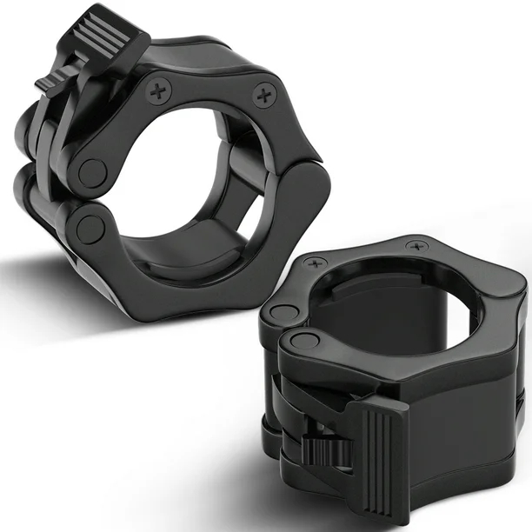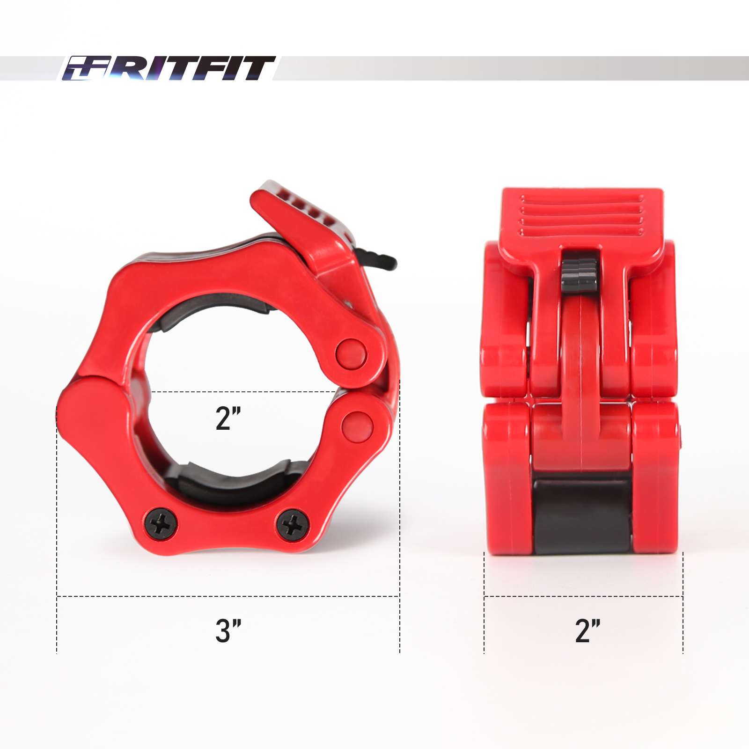

# 

# 

# **Dimensions**

**Arduino Nano 33 BLE Sense**

* **Dimensions**: 45 mm (length) × 18 mm (width) × 13 mm (height, including headers).
* **Source**: [Arduino Forum](https://forum.arduino.cc/t/what-are-the-dimensions-of-the-nano-33-ble-sense-with-heeaders/657854)

**TP4056 LiPo Charging Module**

* **Dimensions**: 29 mm (length) × 17 mm (width) × 10 mm (height).
* **Source**: [Hotmcu.com](https://www.hotmcu.com/tp4056-micro-usb-5v-1a-lithium-battery-charger-module-p-145.html)

**3.7V LiPo Battery (1000mAh with JST connector)**

* **Dimensions**: 52 mm (length) × 34 mm (width) × 5 mm (thickness).
* **Source:** [**Amazon.com: YDL 3.7V 1000mAh 503450 Lipo Battery Rechargeable Lithium Polymer ion Battery Pack with PH2.0mm JST Connector : Health & Household**](https://www.amazon.com/1000mAh-battery-Rechargeable-Lithium-Connector/dp/B07BTV3W87?utm_source=chatgpt.com)

**MCP1700 Voltage Regulator**

* **Dimensions**: measuring approximately .175-.205 in (width) x .170-.210 in (length) x .125-.165 in (height)
* **Source**: MCP1700 Datasheet

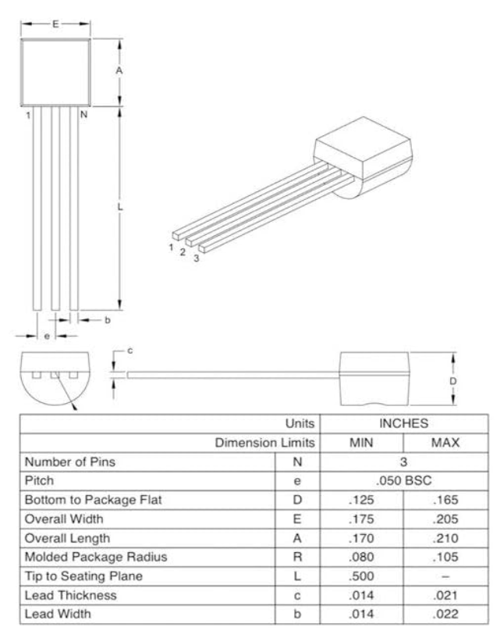

**1µF Ceramic Capacitor**

* **Dimensions**: measuring approximately **15 x 5.7x 3mm**
* **Source**: [Cermant 100pcs 1uf 105 Multilayer Monolithic Ceramic Capacitor MLCC: Amazon.com: Industrial & Scientific](https://www.amazon.com/Cermant-Multilayer-Monolithic-Ceramic-Capacitor/dp/B0D2H87Q32/ref=sr_1_4?dib=eyJ2IjoiMSJ9.nl4sOcJ7qgTAqrB0l60YMNaCeAbs2C1PFsr-ElGbAcNqnCBNma9q-HzHP1wHeJNeeQg00DDlp-D0RyDvv9xLzzsR2a1qqYRV6ZL-7FwQCWkoslHwtcNkfLcpvVqfCO1nudr6LwkuRkiCOwC8Zf2rQ3rYDpay6BfvSKQOSIEwqaveSa9KjNJA0Qgm1hsp1GwejCYuUNalV23DqNjFX5HVzbvvwAsvYwdNNhbdTJ9J0b0.xAzb9fJsREk8Kf9PiBdszwn-OhavTOqiqNyo4-Ybkt4&dib_tag=se&keywords=ceramic%2Bcapacitor%2B1uf&qid=1737093679&sr=8-4&th=1)

# 

# 

# 

# **How Electronics Are Connected**

**1. LiPo Battery** → **TP4056 Input (B+/B-)**:

* Connect the battery’s JST connector to the TP4056's input (B+ and B- pins).
* Red wire (positive) → B+.
* Black wire (negative) → B-.

**2. TP4056 Output (OUT+/OUT-)** → **MCP1700 Input**:

* TP4056 OUT+ → MCP1700 VIN (Input pin).
* TP4056 OUT- → MCP1700 GND.

**3. MCP1700 Output** → **Arduino Nano 33 BLE Sense**:

* MCP1700 VOUT → Arduino 3.3V pin.
* MCP1700 GND → Arduino GND pin.

**4. Capacitor Across MCP1700**:

* Place the 1µF ceramic capacitor:
  + One lead to MCP1700 VIN.
  + One lead to MCP1700 GND.

# **Basic Sketch**

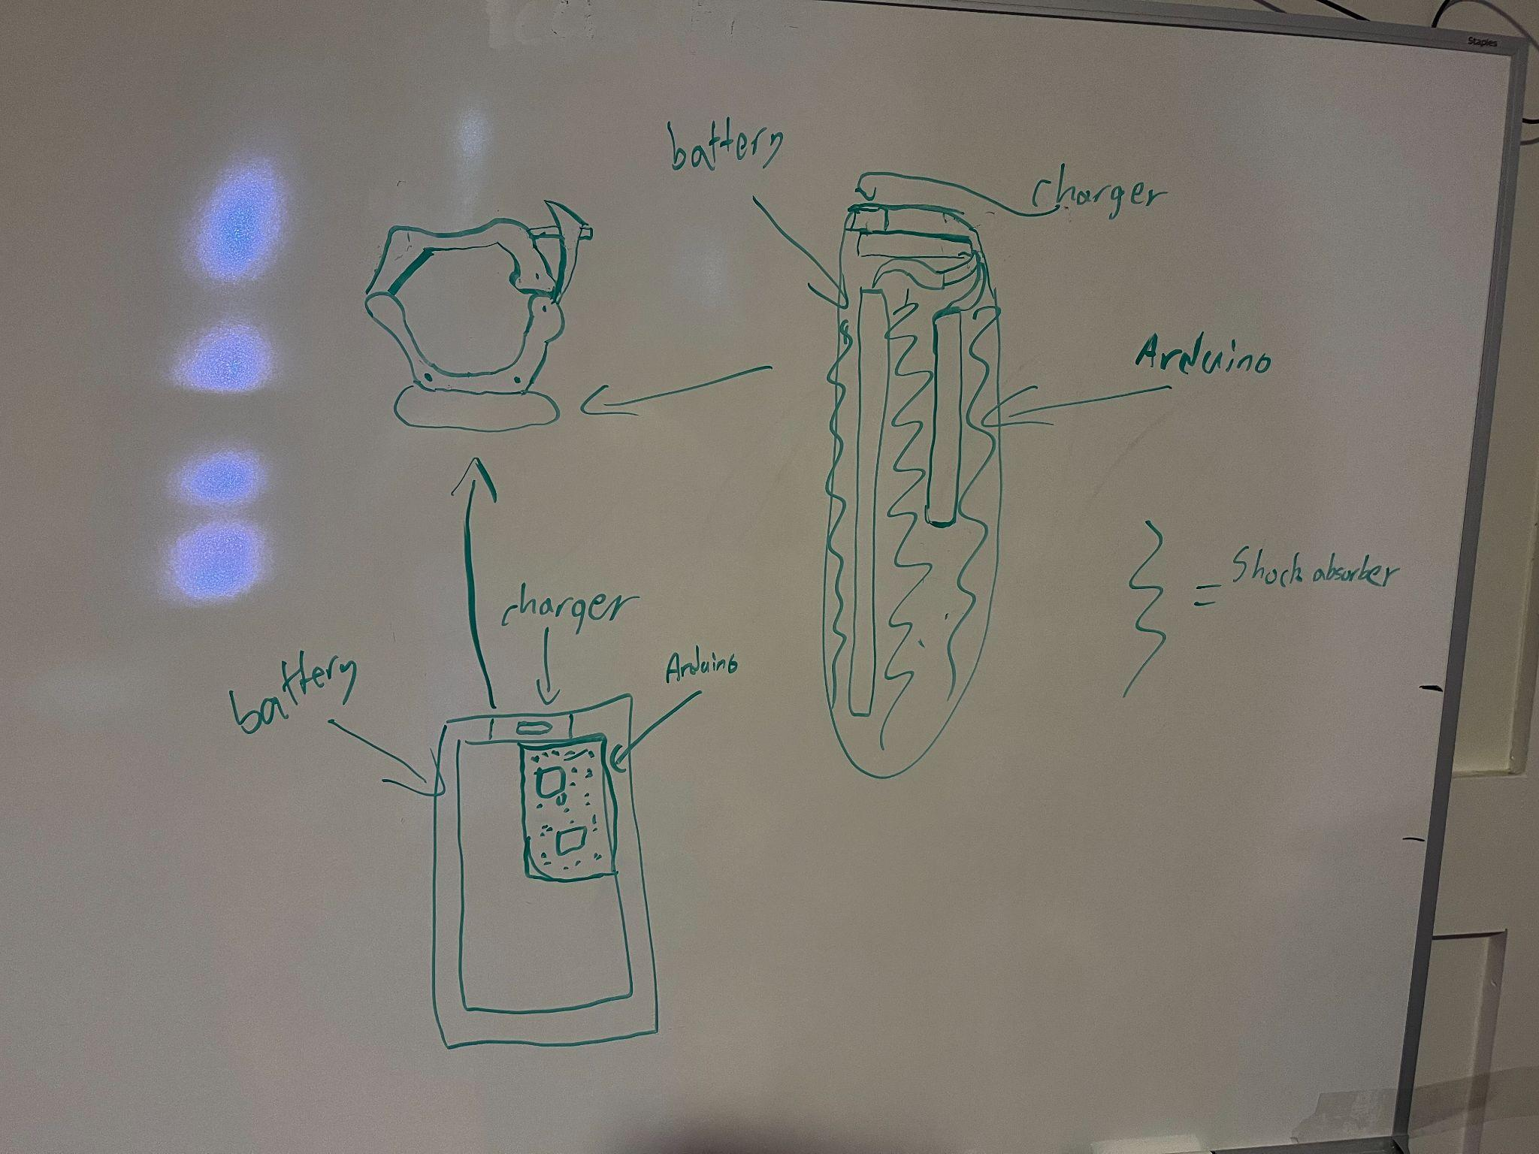

# 

(Capacitor and regulator not pictured)

# **Additional:** The biggest influential factor to this design will be the fact that it needs to be as durable as possible, especially internals so we can minimize hardware issues. We are currently unclear how the shock absorber will fit exactly. Right now our idea is that we will put in some sort of rubber shock absorber we can then carve out so the pieces fit in tightly and secured. If you have a better idea how this can be/is usually done we’d appreciate any feedback. Also we obviously need a way to access the internal compartment which we are unsure what would be the best design for that for our use case.

Another potential point of concern would be the quality of the clip. We are intending on having the clip be 3d printed but are unsure how to ensure that the clip is quality in the way that it stays clamped and doesnt open when the barbells is dropped.

# 